What if . . . in the near future . . . something very bad happened?

*wait for the*

All Clear

Adapted from the stage play

by Eugene Stickland

**A SubGrey Independent Film Production**

**Partnership Prospectus**

Copyright SubGrey Productions Ltd. 2018. All Rights Reserved.

**Introduction**

For decades, the opportunities to direct or produce an independent film, with effective financial backing, has always been notoriously difficult. This has meant that important and relevant projects are lost, even though they could entertain, make a vital social statement and become commercially viable. “*wait for the* ALL CLEAR” is one of those projects that has an important role to play, within the “Independent Film” market.

Currently, the industry has made significant technological advances. With the eruption of online media, “the many” now have the ability to make movies of varying degrees. The side effect of this is a massive amount of online short films, some feature length films and has simply created content that could now be akin to “white noise”. Moreover, this tends to dilute the pool, which inevitably inhibits opportunities for viable projects, talented artists, technicians, etc. This gives them little chance to demonstrate their justifiable talent and creativity, as well as, producing a body of work that would be financially and artistically successful.

**Historical**

SubGrey Productions Ltd is a “Not for Profit” organisation. Our mission is to create film and theatrical projects that would break the mould of the current traditional production making cycle. We showcase the vastly talented unknown personnel and present a body of work that would entertain and resonate with a wide demographic audience. We can do all this and demonstrate commercial viability. Our entire existence is to “Educate, Motivate and Inspire” performing arts students and aspiring unknown actors. We offer them the opportunity to gain experience in a commercial environment that would normally remain beyond their reach.

We are an equal opportunities organisation and inclusive to all gender, ethnic and minorities. We operate a zero-tolerance policy against discrimination of any kind.

“*wait for the* ALL CLEAR” (a black comedy drama) would stand out as a serious metaphor and reflection of “real world” events of current affairs. It reminds us all and offers a warning of the continuing breakdown of communities and the slow but steady disintegration of social behaviour, when faced with a crisis.

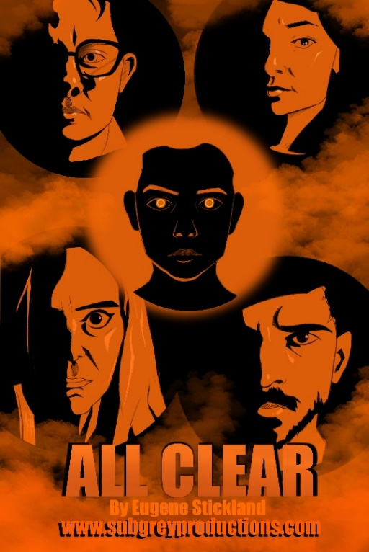

[**https://www.youtube.com/watch?v=PNZDWW5bJNE**](https://www.youtube.com/watch?v=PNZDWW5bJNE)

**wait for the ALL CLEAR**

*Synopsis*

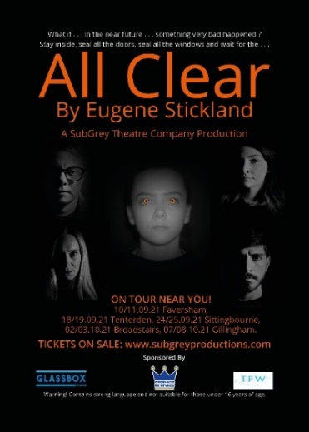Delaney Ford and his family are trapped, after witnessing the sound of sirens and distant explosions in every direction, which were getting ever closer. **Then a strange orange fog descends.** All they can do is to take refuge in their home and seal the doors and windows.

While Delaney sullenly sits at his desk, realising that they will be isolated indefinitely, he hopelessly tries to write his first book of poetry. All he manages to achieve is the slow consumption of his last bottle of Scotch. The other family members aimlessly wander in and out of the lounge, with a desperate need to connect with the outside world and each other, but seem unable to communicate or comprehend what has happened.

Maddie, Delaney’s wife, wants to leave, in the larger sense. Billie, their precocious adult daughter sees current events as an irritating inconvenience and simply wants her mobile phone, Facebook, and Simon (her boyfriend). **But there’s something wrong with Bobby.** Their non-binary gendered, teenage sibling, has been mysteriously damaged by the fog and is somehow stuck in a kind of aphasic verbal loop, absurdly repeating the last things remembered at the moment of the attack, whilst outside the local “Co-Op” store. Complicating matters further, is the coincidental and suspicious appearance of a German Architect called Braun. He has some sort of connection with Maddie and Delaney’s past. His sudden and untimely appearance has further driven the wedge between husband and wife. This potentially makes an unpleasant atmosphere even more uncomfortable and fuels the family friction. Could this conflict create an even more explosive event of their own? It is now three days after the event, with **no power, no water, no communication and no sign of civilisation.**

**Storyboard Highlights**

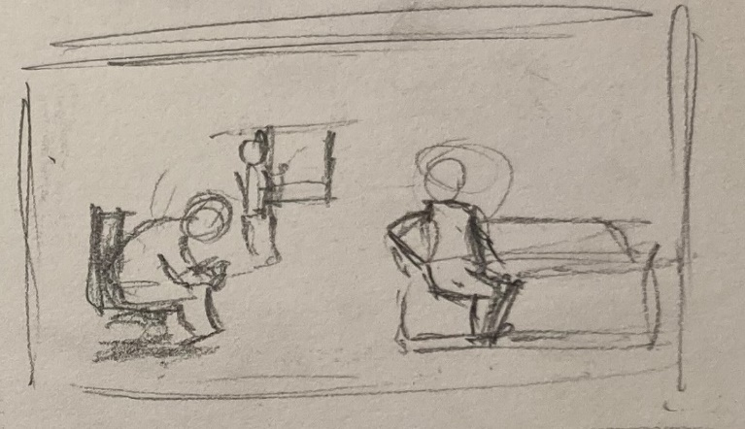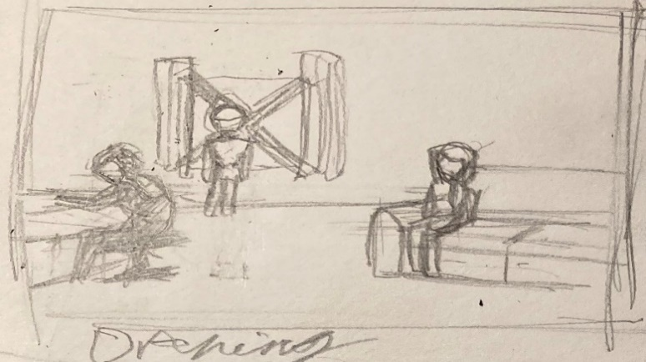1 SB – Opening Shot 2 SB – Opening Dialogue

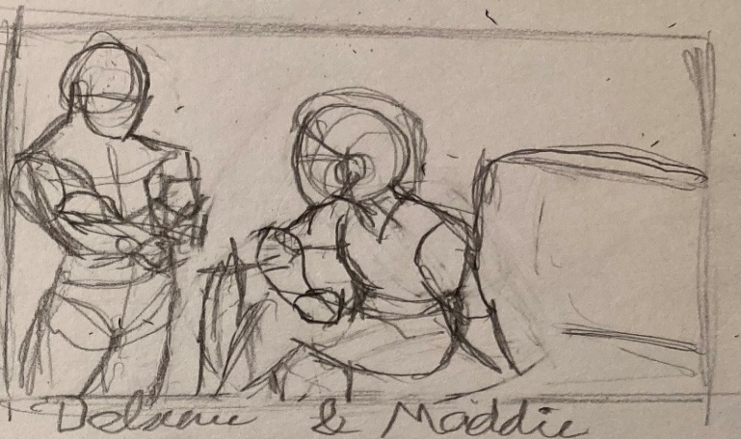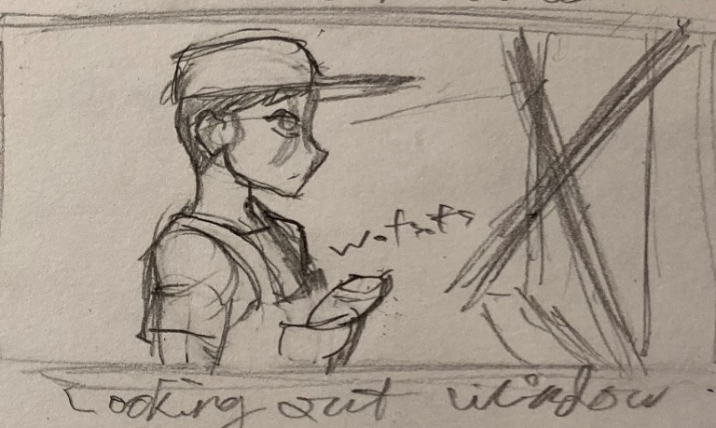3 SB – Bobby Position 4 SB – Maddie & Delaney

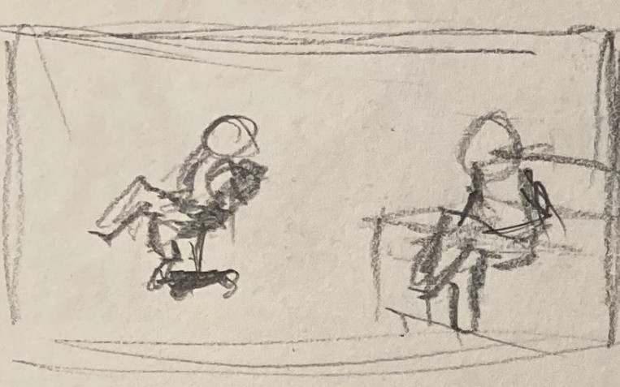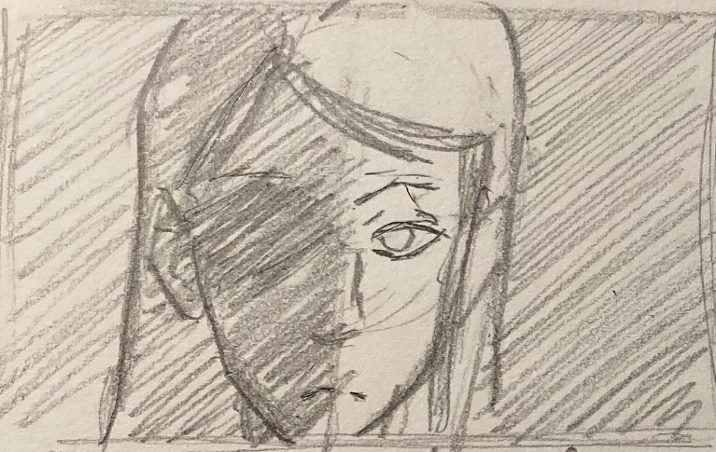5 SB – Maddie Monologue 6 SB – Delaney & Maddie

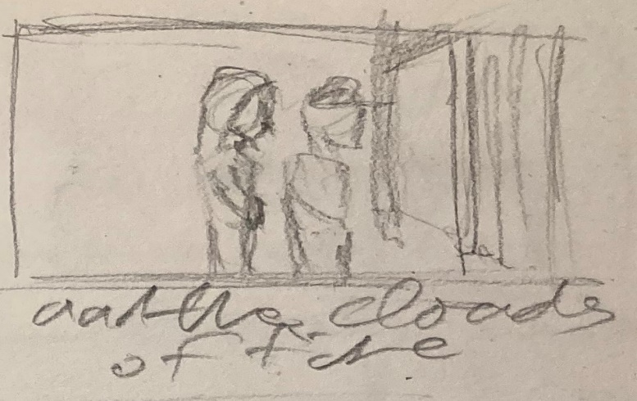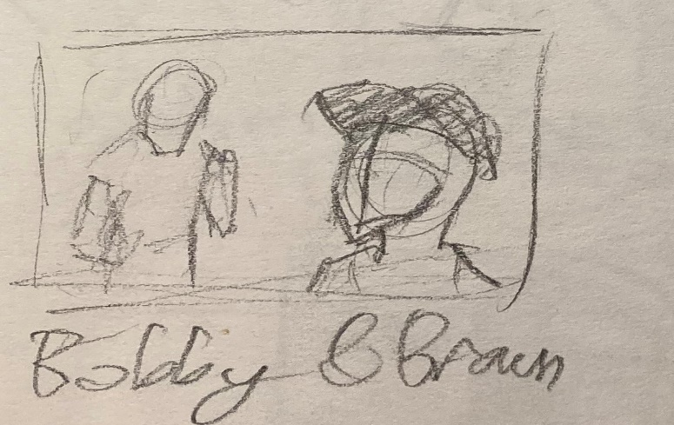7 SB – Maddie & Bobby 8 SB – Bobby & Braun

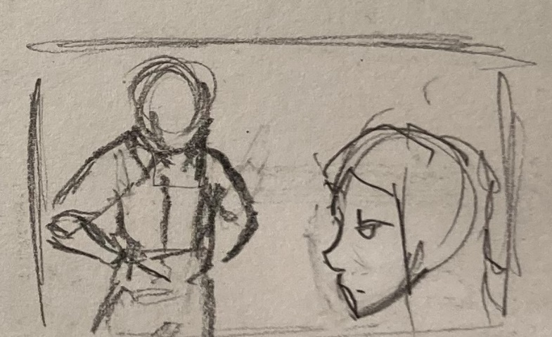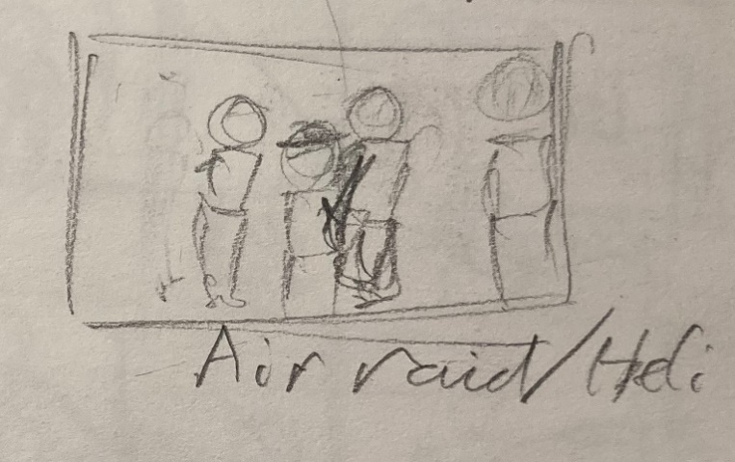9 SB – Delaney & Maddie 10 SB – Air Raid Tableau

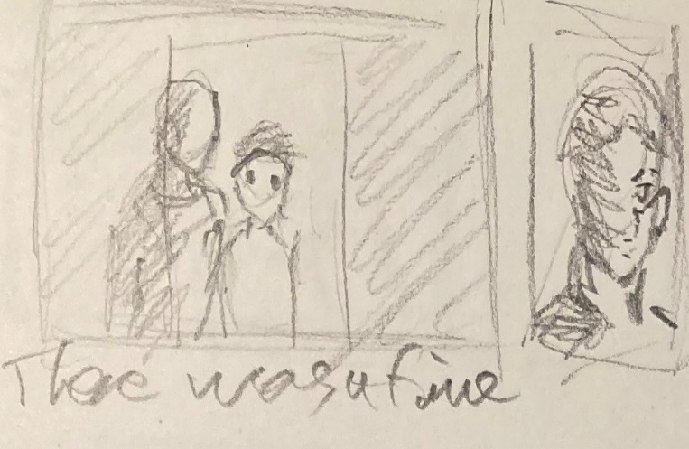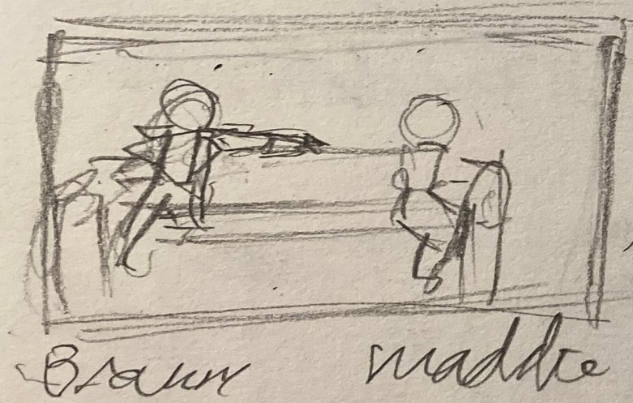11 SB – Maddie & Braun 12 SB – Delaney & Bobby

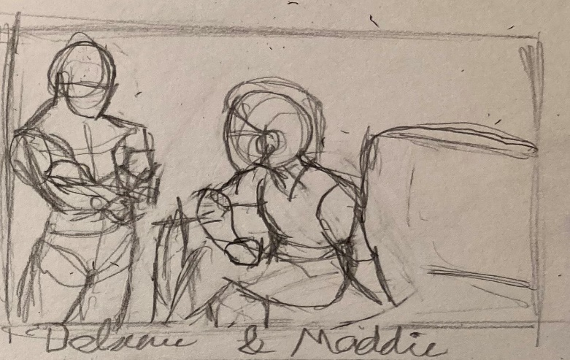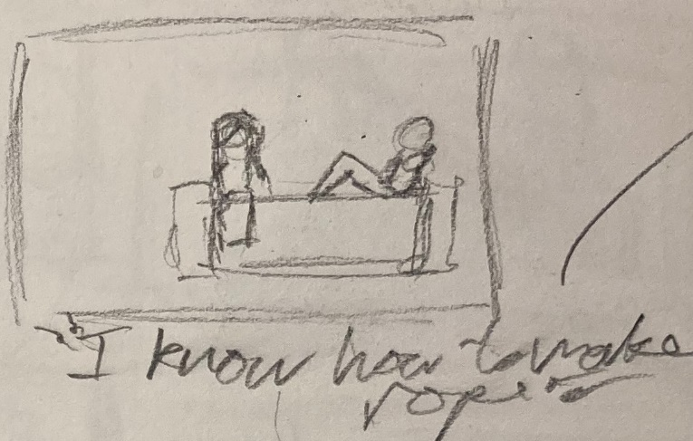13 SB Delaney & Maddie 14 Maddie & Billie

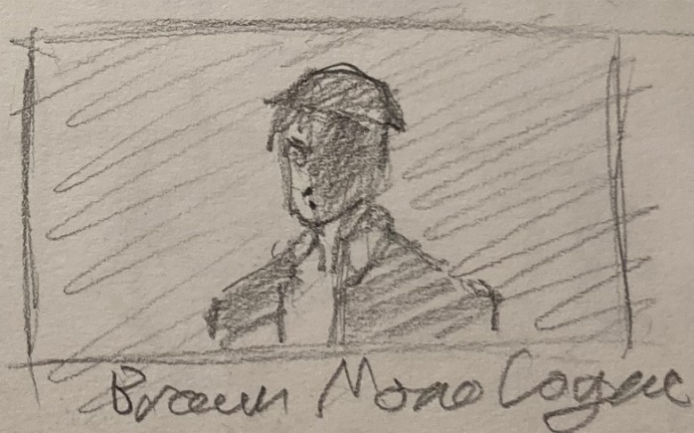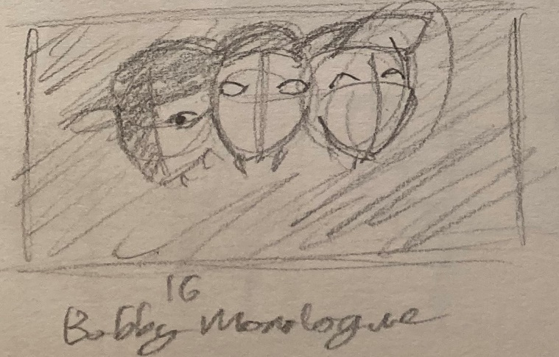15 Braun Monologue 16 Bobby Monologue

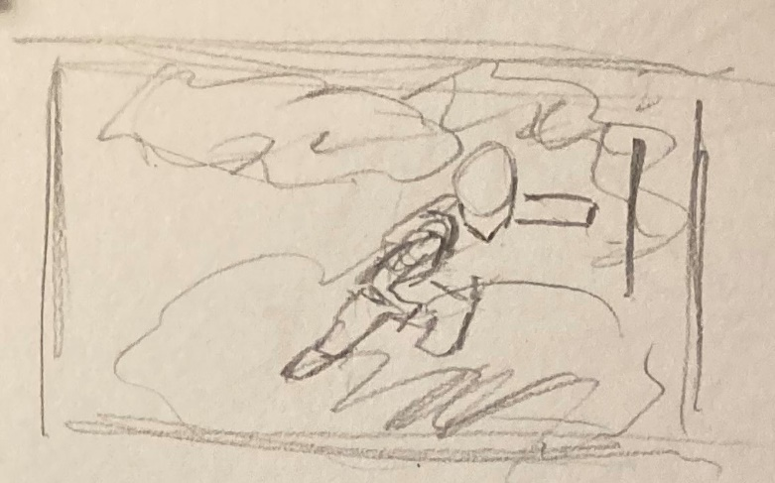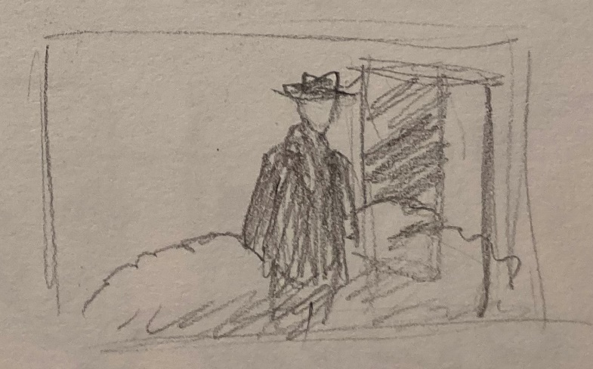17 SB – Braun Exits 18 SB – Fog Penetration

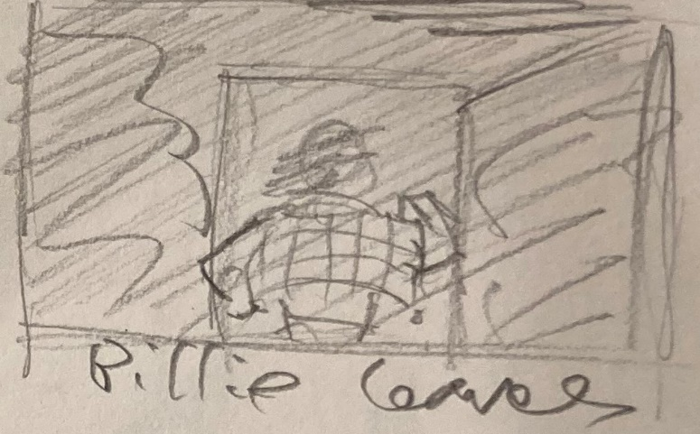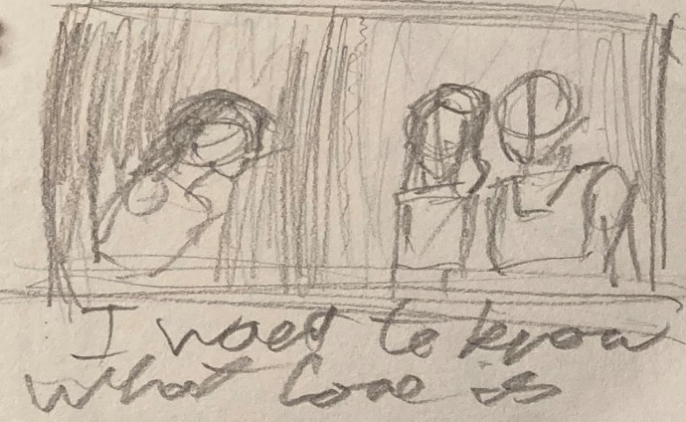19 SB – Billie Conflict 20 SB Billie Exits

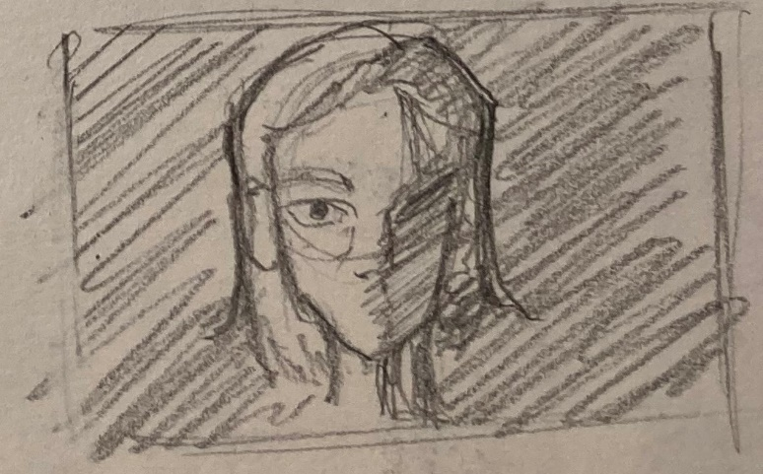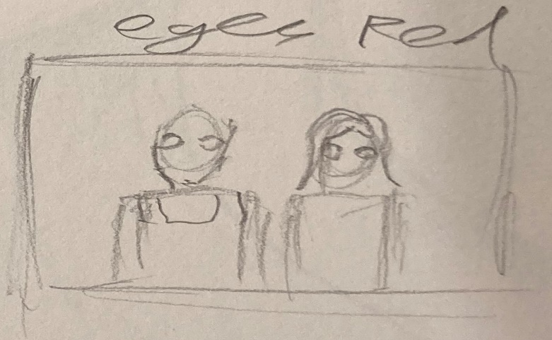21 SB – Delaney & Maddie End Scene 22 SB – Bobby Scene After End Credits

**Biographies**

***Eugene Stickland - Writer***

Eugene was born in Regina, Canada. He studied at the University of Regina in music, as a piano performance major, but switched to English and graduated with an “Honours” BA in English, then went on to complete the course work for an MA. Attending York University in Toronto, where he completed an MFA in Theatre, specifically playwriting and dramaturgy. After graduating, Eugene and some York classmates formed the ACT IV Theatre Company, producing his early plays “The Family”, “Darkness Of The Edge Of Town” and “Quartet”.

Returning to Regina, he taught at what is now known as the First Nations University. It was at this time his daughter Hanna came into the world (1992). In Calgary (1994) saw his first major production at Alberta Theatre Projects of the hit play “Some Assembly Required”, which went on to have over 100 productions worldwide. He wrote nine more plays. during a 10-year residency at ATP, including “All Clear” in 2004. In 2009 Eugene wrote a play for his friend Joyce Doolittle titled “Queen Lear”. Following his time at ATP, Eugene wrote a very popular weekly column for the Calgary Herald. In 2015 he published his first novel, “The Piano Teacher”, which received the W.O. Mitchell Award. Eugene is completing a new novel, “Fragments”, as well as a new play based on the life of Saskatchewan-born American artist Agnes Martin. He lives alone in the Beltline neighbourhood in Calgary.

***PD Slaughter (Director/Producer)***

Paul Slaughter was born and raised in South London. Started his acting journey in 1976 by joining The Battersea Arts Centre Workshop, performing street theatre and contemporary theatre. Following on from this, he became part of the original “Fringe” movement (in London), appearing in stage plays that toured such venues as; Deptford Theatre, The Roundhouse, Drury Lane Arts Lab, The Vauxhall Tavern, Finborough Theatre, among other notable venues.

During this time, he attended Morley College (Lambeth), for three years, where he received training from RADA, LAMDA and E15 directors. This inspired and maintained his desire to feast on the “Fringe” stage. In the 1990’s, after spending time in the music industry and working as a Telecine/Video Editor, he took various opportunities to coach and direct “Youth Theatre” projects. His philosophy for motivating and guiding potential talent, enabled him to nurture young actors, of which a few went on to train at E15, LAMDA and Guildhall.

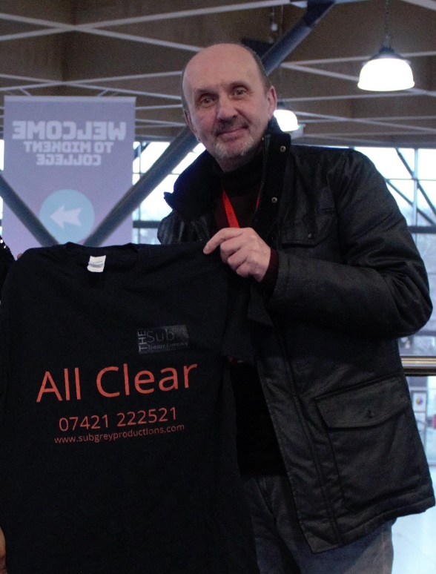In 2000 he created SubGrey Productions. He filmed and directed “Pop Promo’s” for unknown musical artists. His concept was to film a promo at a fraction of the cost, but maintaining a broadcast standard that effectively promote the material. However, after some minor success and due to a serious illness, he ceased his performing arts involvement. He married in 1997 and raised one child. In 2007 he returned to the arts, directing theatre projects on a local level, to promote and support “Performing Arts Students” and locally based unknown actors. This gave him an idea.

SubGrey Productions was created in 2014, with an ethos to provide the highest professional support to students and actors at a fraction of the cost. In that same year, by accident, he discovered “All Clear” a stage play by Eugene Stickland. This play was well known and performed in other parts of the world, but had never been seen in the UK.

After negotiating the UK and European rights, The SubGrey Theatre Company toured the piece in 2021 throughout the Kent area, with a view to extending to provisional theatres and festivals. The project and inaugural tour took three years to perform, due to the Pandemic and nearly closed the project permanently. But determination and considerable support from the cast and crew, it received outstanding reviews from local press, radio and audiences, throughout Kent.

Finally, as COVID-19 is still having a profoundly negative effect within the “Live Theatre” scene, he decided that this play lends itself and needs to and is commercially viable to be made as an independent movie. After reworking the script over the last 12 months and hundreds of hours of planning, “*wait for the* ALL CLEAR” is ready for filming.

***Mark Petitt CDA (Casting Director)***

Mark has been working professionally in the entertainment industry for over thirty years with a career that has encompassed many aspects, from performing and teaching, to casting and producing, and is a full member of the Casting Directors Association. As a graduate of the Guildford School of acting, coming from a performance background has allowed Mark to not only build a large industry network, but as a Casting Director to share an empathy and understanding with every actor he meets, as he spent many years on the other side of the table!

Mark launched In House Casting in 2010, offering a bespoke casting service for both stage and screen productions. With a social media following of over 35,000 industry professionals, the primary objective of In House is to source the best talent for any project!

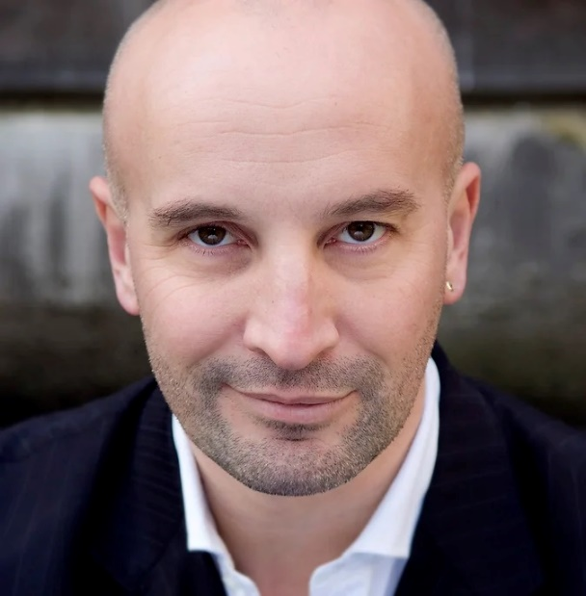

**All Clear – The Theatrical Tour**

SubGrey Productions Ltd., as part of its mission, initiated a theatre tour of the play. All Clear had never been performed in the UK before, which offered us an exclusive opportunity. So, “The SubGrey Theatre Company” was created and recruited a wide range of personnel from a variety of backgrounds. The Company’s concept was to offer a unique opportunity, to performing arts students, allowing them to gain a “Real World” experience of the commercial theatre industry. These students worked alongside professional artists. This “proof of concept” succeeded in its objective. The students and professionals alike, gained a valuable experience that was previously unavailable. It motivated, inspired and built a foundation for future career opportunities.

SubGrey found the play in 2014. In late 2018, after several false starts, funding issues and changes in personnel, we finally achieved the creation of a brilliant cast and crew. In mid-2019 rehearsals began, and the tour was scheduled to commence in April 2020. In March 2020, with an ironically spooky coincidence and three weeks prior to the start of our tour, the Worldwide Pandemic happened. Our set and equipment had to be placed in storage and the personnel were laid off. It was almost like we predicted the reality of the “real life” events that unfolded.

Our organisation spent the following eighteen months consulting with multiple contacts within the UK Theatre industry. But the industry catastrophically collapsed. We also spent this time to apply to the Government for funding and replacement of losses, which amounted to thousands of pounds. Despite our continuous lobbying, applications and communication, we did not receive one penny of financial support. However, we were able to plan a relaunch of the tour and reassembled the cast and crew. The tour took place in the Autumn of 2021, received critical acclaim and succeeded in its “Proof of Concept”. This has enabled our organisation the opportunity to now produce an independent film. We have completed Pre-Production Planning and now seek the funding to commence full production.

For video highlights (4 clips), please visit the SubGrey Productions YouTube Channel.

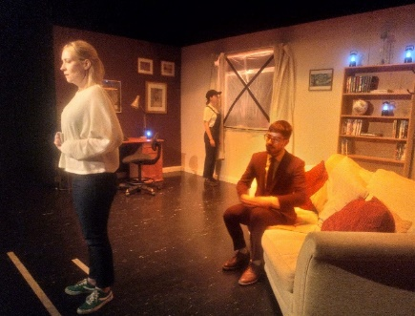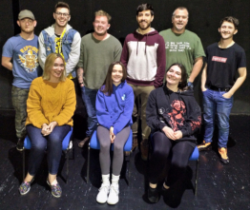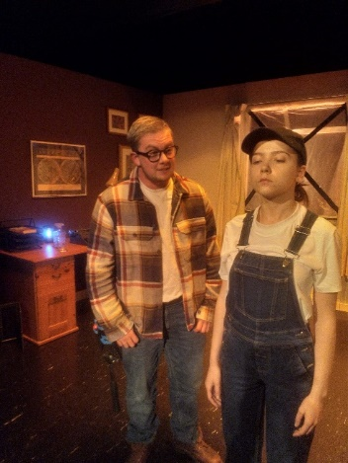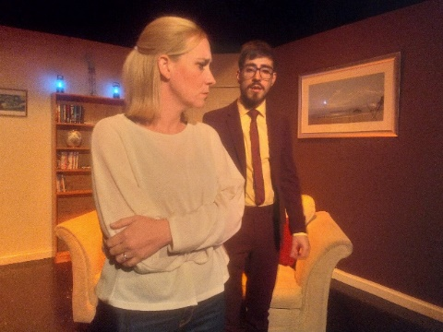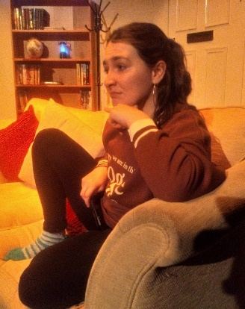

**Festival And Competition Entry**

The purpose of entering “*wait for the* ALL CLEAR” into festivals and competitions would create lucrative promotional possibilities. Not only would it be a cost-effective route to raise the profile of the film but offer us key networking opportunities to distribution routes and further monetise potential revenue streams.

The following list shows targeted UK festivals, covering a wide-ranging demographic. This includes a diverse selection, both large and small events. After researching 189 listed festivals, we have selected 23 which are the most relevant to the film, its genre and meets the entry criteria. Most of these run a competition, with awards, within the festival period. Entry fees vary and some are free of charge to enter. The fees would be covered by SubGrey.

*Source: British Council Film Festivals List.*

*Stage 1 UK Festivals Location Month Fees*

Glasgow Film Festival Glasgow Feb/March Yes

Manchester Film Festival Manchester March Yes

Harrogate Film Festival Harrogate March No

Berwick Film and Media Arts Festival Berwick-upon-Tweed April Yes

Borderlines Film Festival Hereford April No

London Independent Film Festival London April Yes

Derby Film Festival Derby May Yes

Edinburgh International Film Festival Edinburgh June Yes

Kinofilm Festival Manchester July Yes

51zero Rochester August No

Barnes Film Festival London September Yes

Bath Film Festival Bath September No

British Urban Film Festival London September Yes

Hackney Film Festival London September Yes

Raindance Film Festival London Sept/Oct Yes

Abandon Normal Devices Manchester October No

BFI London Film Festival London October Yes

Bolton International Film Festival Bolton October Yes

Cambridge Film Festival Cambridge October Yes

London Arthouse Film Festival London October Yes

Southampton Film Festival Southampton October Yes

Crystal Palace International Film Festival London Oct/Nov Yes

Leeds International Film Festival Leeds November Yes

**So, There You Have It!**

In summary, SubGrey Productions Ltd., a “Not for Profit” company, have exclusive rights to film and distribute “*wait for the* ALL CLEAR” with the full support of the playwright. The original stage play was performed in Canada, USA and other countries, but never within the UK. We toured the play with a rich mixture of professional and student cast and crew. The tour enjoyed critical acclaim from audiences and regional press/radio. We have a lucrative opportunity to bring “*wait for* the ALL CLEAR” to the screen and appeal to a wide demographic of audiences.

The film offers a strong social message and will be made in keeping with our ethos and methodology, to introduce new, highly talented unknown professional and student personnel to the performing arts industry. We are an equal opportunities organisation and operate a zero-tolerance policy against discrimination of any kind.

This project not only enables our team to gain “real world experience”, that is normally beyond reach, but also achieve a commercially profitable venture. We will produce a socially relevant, highly entertaining and “thought provoking” film, that highlights the multiple crises’, taking place within recent and current times, both in the UK and the wider world.

We have fully researched and verified all aspects of the entire project. From equipment to locations. From crew to post production. From distribution to extensive entries to “film specific” festivals. Moreover, we can produce a high quality and fully professional film, at a considerably lower cost. Subgrey Productions has previously and repeatedly proved that these type of projects and productions can be successfully created, without the need for “eye watering” bank busting budgets.

We seek your partnership, in a project that has a feasible plan, a commercially viable proposal and a real potential for commercial success, whilst maintaining our key mission philosophy to

**Educate, Motivate and Inspire!**

**We Thank You for Your Consideration**

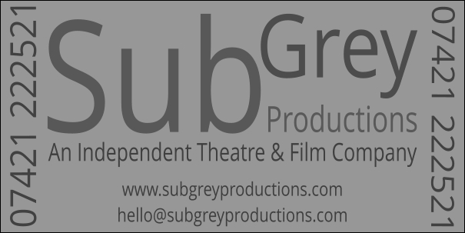

Authored By: PD Slaughter

Producer/Director

SubGrey Productions Ltd.

hello@subgreyproductions.com

07421 222521